| Requirements and Design Specification Document  **<Project Title>**  Project Code:462  Advisor:  Sir Muhammad Adreess  Project Team:  Rohma Noor 192400020  Faran Zahid 192400009  Aroosh Khizer 181370162  Nayab Fatima 181370175  Submission Date:  26-july-2022 |
| --- |

**Document Information**

| **Category** | **Information** |
| --- | --- |
| Customer | Anybody who wants to transfer goods |
| Project | LoadEx |
| Document | Requirement Specifications |
| Document Version | 1.0 |
| Identifier |  |
| Status | Draft |
| Author(s) | Ruhma Noor 192400020,  Faran Zahid Sandhu 192400009  Nayab Fatima 181370175  Arosh khizar |
| Approver(s) | Sir Muhammad Adrees |
| Issue Date |  |
| Document Location | Gift University |
| Distribution |  |

**Definition of Terms, Acronyms and Abbreviations**

*This section should provide the definitions of all terms, acronyms, and abbreviations required to interpret the terms used in the document properly.*

| **Term** | **Description** |
| --- | --- |
|  |  |
|  |  |
|  |  |
|  |  |
|  |  |
|  |  |
|  |  |
|  |  |

Table of Contents

1. Introduction 4

1.1 Purpose 4

1.2 Scope 4

1.3 Definitions, Acronyms, and Abbreviations 4

1.4 References 4

1.5 Overview 4

2. Overall Description 4

3. Specific Requirements 5

3.1 Functionality 5

<Functional Requirement One> 5

3.2 Usability 5

<Usability Requirement One> 5

3.3 Reliability 5

<Reliability Requirement One> 6

3.4 Performance 6

<Performance Requirement One> 6

3.5 Supportability 6

<Supportability Requirement One> 6

3.6 Design Constraints 6

<Design Constraint One..> 7

3.7 On-line User Documentation and Help System Requirements 7

3.8 Purchased Components 7

3.9 Interfaces 7

User Interfaces 7

Hardware Interfaces 7

Software Interfaces 7

Communications Interfaces 7

3.10 Licensing Requirements 7

3.11 Legal, Copyright, and Other Notices 7

3.12 Applicable Standards 7

4. System Architecture 8

5. Use Cases 8

5.1 Use Case Diagram 8

5.2 Use Case Description 8

6. Detailed System Design 9

7. Research and Development 9

8. Learning Outcomes 9

9. Practical Applications 9

10. Supporting Information 9

# Introduction

LoadEx is an online website for a transferring goods from one place to another

Within or outside the city. It is a secure system. It has the ability to tell expected money before traveling .It has the ability to show the user exact location. It has the ability to pay online through paypal.

## Purpose

We proposed a real time goods transferring and tracking system. This enable customer to find out to location of the vehicle so there goods would not get late or not arrive at the stop. The main purpose of this application is to provide exact location of the vehicle that transfer their goods and provide security. This application is also estimate the time of the particular destination.

## Scope

* Chat with admin.
* Live location.
* Payment method online through paypal, and by hand payment.
* Helpers will be provided. Or
* Bargaining of payment is also possible. (You can set money according to your budget).
* Availability of a vehicle.
* Can select pickup time.

## Definitions, Acronyms, and Abbreviations

BR Business Requirement

FR Functional Requirement

UR User Requirement

NR Non-Functional Requirement

# Specific Requirements

**Business requirements:**

BR-01: the system shall login with only corrected admin ID

BR-02: the system shall track customers’ orders.

BR-03: The system shall collect data of imports and exports of customer goods.

BR-04: The system shall automated the whole process so no manual records needed.

BR-05: the system shall check the data of the shipping agent.

BR-06: The system shall collect payment online through paypal.

BR-07: the system shall check loading and unloading of imports and exports of customer goods

BR-08: the system should be able to track locations of trucks in real time

BR-09: the system should be able to register drivers

BR-10: the system should be able to register customers

BR-11: the system should be able to provide a facility to chat with customer care.

BR-12 the system should allow all their users to change passwords.

BR-13: the system should easily be accessible.

BR-14: the system should provide facilities to admin to update vehicle information.

BR-15: the system should provide facility to customers to cancel bookings

**User Requirements:**

**As an admin:**

UR-01: admin shall be able to login

UR-02: I shall be able to check the availability of vehicles.

UR-03: I shall check live location of truck which is holding customers goods

UR-04: I shall be able to check bookings.

UR-05: I shall be able to check records of customers

UR-06: I shall be able to update payments.

UR-07: I shall be able to register drivers.

**As a customer:**

UR-09: customer shall register myself..

UR-10: I shall be able to book a vehicle.

UR-11: I shall be able to check live location.

UR-12: I shall bargain about payment.

UR-13: I shall be able to chat when I face problem.

## Functionality

FR-01: The system shall provide facility to login

FR-02: The system shall provide facility to cancel bookings.

FR-03: The system shall provide facility to logout

FR-04: The system shall provide facility to book a vehicle.

FR-05: The system shall provide facility to check the Availability of a vehicle for that specific time.

FR-06: The system shall provide the facility to select the pickup time.

FR-07: The system shall provide facility to provide helpers to customers

FR-08: The system shall be able to provide the facility to users to chat with customer care..

FR-09: The system shall provide the facility to check live location of vehicle

FR-12: The system shall provide facility to pay online through paypal.

FR-13: The system shall provide facility to pay cash on delivery.

FR-14: The system shall provide facility to bargaining about payment

FR-15: the system shall provide facility to select location of drop-off.

FR-17: the system shall provide facility to register drivers.

## Usability

The main use case must be accessible from the main screen.

Most novice users can learn to operate major use cases without any assistance.

## Reliability

* System shall be able to available 24/7
* System shall be bug or error free
* System Mean time to repair shall be 3 hours
* System shall be able to recover itself within seconds

## Performance

* System shall be able to render user search with no delay
* System shall be able to store, add, detail within 0.03 second.
* System shall be able to quickly respond to conversation between customers.
* System shall be reliable in providing all its services.

## Supportability

* System shall be able to run smoothly on minimum 1 gb ram
* System shall be able to support all browsers.
* The system shall support only the English language.

## Design Constraints

* System frontend should be designed in html
* System backend should be designed in php ,laravel
* System should be store its data in Mysql database

## On-line User Documentation and Help System Requirements

***Video tutorial***

## Purchased Components

No

**Interfaces**

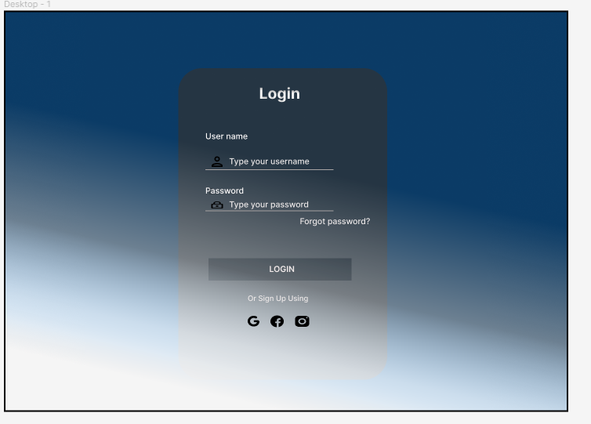

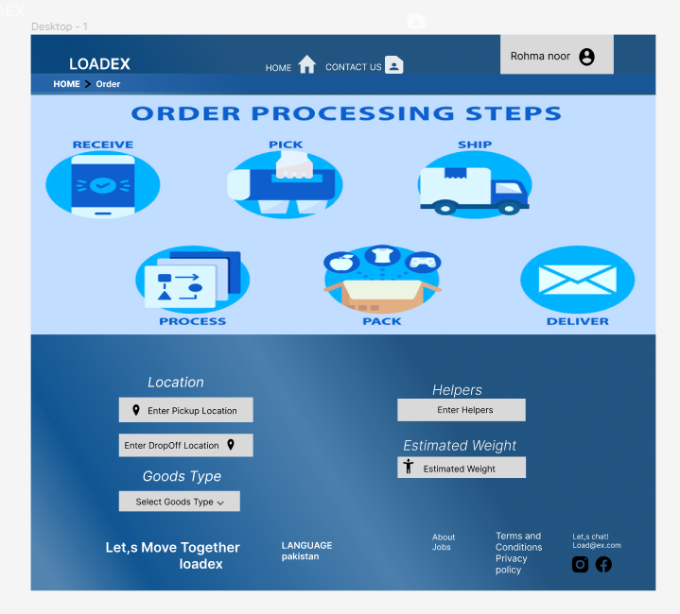

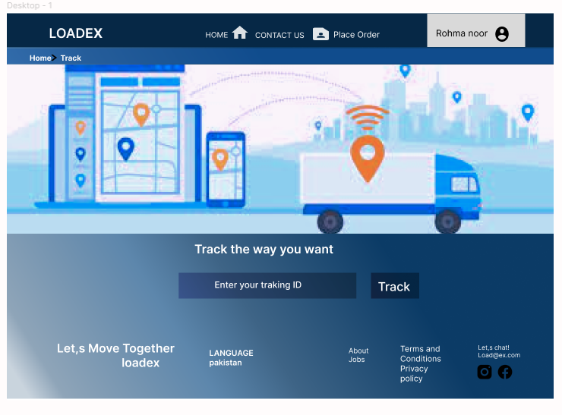

## Use Case Diagram

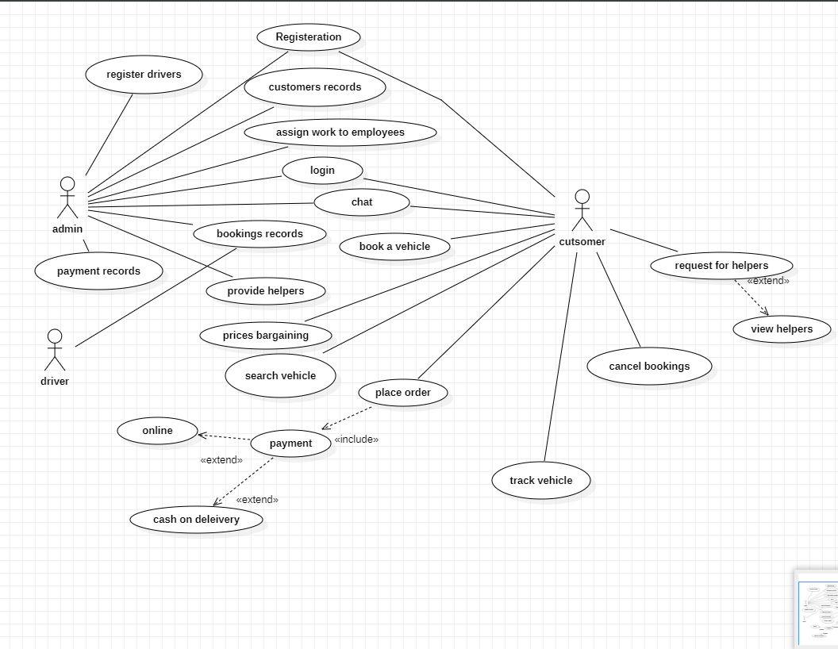

**Use Case Description**

**Admin**

**UC -1** : Login

**UC -2** : Register drivers

**UC -3** : Customer record

**UC -4** : Assign work

**UC -5** : Chat

**UC -6** : Provide helpers

**UC -7** : Payment record

**UC -8** : Provide discount

**Customer**

**UC -9** : Chat

**UC -10** : Book a vehicle

**UC -11** : Price bargaining

**UC -12** : Payment

**UC -13** : Search vehicle

**UC -14** : Set pick up time

**UC -15** : Set drop up location

**UC -16** : Track vehicle

**UC -17** : Cancel booking

**UC -18** : View helpers

**Driver**

**UC -19** : Booking record

**Use Case Scenarios:**

**Admin**

| Use case Id: | UC-1 |
| --- | --- |
| Use Case Name: | Login |
| Actor: | Admin |
| Description | The admin will login in the system by click on the login button. |
| Trigger: | The admin clicks requests to login. |
| Pre-conditions: | Admin must be registered in to the system. |
| Post-conditions: | • The admin will be successfully logged into the system.  • The admin will have access to the functions of the system. |
| Normal Flow | • admin clicks on the login button  • The system loads the login form with fields (username, password)  • The admin enters the username and password.  • Admin clicks on the “Login” button  •  •  • The system display adim homepage.  • The Usecase end.  • |
| Exceptions: | In case of any technical or network issue. The system will bring back to you the previous state. |
| Alternative Flows | Missing Admin Id &password  The system display message missing admin id or password.  Invalid Admin ID&password  The system display message invalid admin id or password. |
| Includes: | None |
| Priority: | High |
| Frequency of use: | One time only for every user. |
| Assumptions: | It is assumed that the user will provide accurate  details. |

| Use case Id: | Uc-2 |
| --- | --- |
| Use Case Name: | Register driver |
| Actor: | Admin |
| Description | Admin register drivers by click on driver registration button. |
| Trigger: | The admin request to registered drivers in the system. |
| Pre-conditions: | The admin must be login into the system |
| Post-conditions: | Drivers successfully registered in the system. |
| Normal Flow | • The admin clicks on the “driver registration” button.  • The system loads the registration form which has some field of information (first name, Last name, Password, Ph. No,CNIC, Address).  • The admin enters the required field.  • The admin will click on the “Register” button  • The system Validates the (first name, Last name, Password, Ph. No,CNIC, Address).  • The system varifies the (first name, Last name, Password, Ph. No,CNIC, Address).  • The system shows the message “User is successfully registered into the system.  • The Usecase end. |
| Exceptions: | In case of a network issue. The system will bring back to you the registration form. |
| Alternative Flows | Missing any field  The system display message fill this field.  Invalid information  The system display message invalid information. |
| Includes: | None |
| Priority: | High |
| Frequency of use: | One time for every driver. |
| Assumption | It is assumed that the admin will provide accurate details. |

| Use case Id: | Uc-3 |
| --- | --- |
| Use Case Name: | Customer Records |
| Actor: | Admin |
| Description | Admin will see customer records. |
| Trigger: | Admin will click on “customer records” menu. |
| Pre-conditions: | • The admin must be logged in to the system.  • The customer must be registered . |
| Post-conditions: | The admin will view customer detail successfully |
| Normal Flow | • The admin clicks on the “View Customer record” from menu.  • The system will show the Customer record. |
| Exceptions: | If the database server is not running. The System will show an exception message. |
| Alternative Flows | If the customer is not registered. The system will show an empty customer record table. |
| Includes: | Customer registration |
| Priority: | High |
| Frequency of use: | Any time admin wants to view Customer detail. |
| Assumption | It is assumed that the customer is already registered |

| Use case Id: | Us-4 |
| --- | --- |
| Use Case Name: | Assign work to employees |
| Actor: | admin |
| Description | The admin will assign work to the divers . |
| Trigger: | The admin click on “assign work” menu. |
| Pre-conditions: | • The admin must be logged in to the system.  • The employees must be registered . |
| Post-conditions: | The admin assign work to the driver successfully. |
| Normal Flow | • The admin click on the “assign work to employees “ from menu.  • The system will display all employees page .  • Admin assign work to employee.  • The system valide the employee id .  • The system varify the employee id .  • The system will successfully assign work to employee.  • Uesecase end |
| Exceptions: | If the database server is not running. The System will show an exception message. |
| Alternative Flows | Not registerd  If the employee is not registered. The system will show not employee registered.  Not availabe  The system display message employee is not available at this time. |
| Includes: | Registered driver |
| Priority: | High |
| Frequency of use: | Any time admin assign work to drivers. |
| Assumption | It is assumed that the driver is already registered. |

| Use case Id: | Us-5 |
| --- | --- |
| Use Case Name: | Chat with customer |
| Actor: | Admin |
| Description | The admin will chat with customer. |
| Trigger: | The admin will click on “chat with customer“ menu. |
| Pre-conditions: | • The admin must be logged in to the system.  • The customer must be registered.  • The customer must be book a vehicle. |
| Post-conditions: | The admin chat with customer successfully. |
| Normal Flow | • The admin click on “chat with customer” menu.  • The system valide the customer id.  • The system varify the customer id .  • The system will display chat room.  • The admin will chat with customer in cause of any query.  • The system send query to customer.  • The usecase end. |
| Exceptions: | If the database server is not running. The System will show an exception message. |
| Alternative Flows | None |
| Includes: | Registered customer , admin |
| Priority: | High |
| Frequency of use: | Any time admin chat with customer. |
| Assumption | It is assume that customer book a vehicle . |

| Use case Id: | Us-6 |
| --- | --- |
| Use Case Name: | Provide Helpers |
| Actor: | Admin |
| Description | Admin will provide helpers to the customers. |
| Trigger: | Admin clicks request “provide helpers” menu. |
| Pre-conditions: | The admin must be logged in to the system.  The customer must be require helpers. |
| Post-conditions: | The admin successfully provide helper to the customers. |
| Normal Flow | • The admin click on” provide helpers “ from menu button.  • The system will show provide helper box.  • The admin will select the helper .  • The system will successfully select helpers. |
| Exceptions: | If the database server is not running. The System will show an exception message. |
| Alternative Flows | Not available  if the helpers not availabe system dispaly message not availabe at this time. |
| Includes: | None |
| Priority: | mediam |
| Frequency of use: | Admin any tim  e select helpers. |
| Assumption | it is assume that admin select helpers. |

| Use case Id: | Us-7 |
| --- | --- |
| Use Case Name: | Payment Record |
| Actor: | Admin |
| Description | Admin check the payment record in any query. |
| Trigger: | Admin clicks on “payment record” from menu. |
| Pre-conditions: | The admin must be logged in to the system. |
| Post-conditions: | The system will show payment record table successfully. |
| Normal Flow | • The admin click on payment record from menu .  • The system valide the customer id .  • The system varufy the customer id .  • The system will show payment record table .  • The admin see the payment record.  • The usecase end . |
| Exceptions: | If the database server is not running. The System will show an exception message. |
| Alternative Flows | If there is not any payment record. It will show no payment record. |
| Includes: | None |
| Priority: | High |
| Frequency of use: | Admin can check payment record any time . |

| Use case Id: | Us-8 |
| --- | --- |
| Use Case Name: | Booking Record |
| Actor: | Admin |
| Description | Admin check booking record of the customer . |
| Trigger: | Admin clicks on “Booking record” from menu. |
| Pre-conditions: | The admin must be logged in to the system.  Customer must be book a vehical. |
| Post-conditions: | Sysetm will display booking record page. |
| Normal Flow | • The admin click on Booking record from menu .  • The system valide the customer id .  • .The system varify the customer id .  • System display booking record page.  • Admin check the booking record.  • the usecase end |
| Exceptions: | If the database server is not running. The System will show an exception message. |
| Alternative Flows | Not book vehical  if the customer not book a vehical the system display not book a vehical. |
| Includes: | None |
| Priority: | Medium |
| Frequency of use: | Admin can check the discount offers |
| Assumption | It is assume that customer avail discount. |

customer

| Use case Id: | Us-9 |
| --- | --- |
| Use Case Name: | Book a vehicle |
| Actor: | customer |
| Description | The customer will book a vehicle for goods transfer from one place to another place. |
| Trigger: | Customer send request “book vehicle” menu. |
| Pre-conditions: | Customer will must be login in the system successfully.  Customer have access to all functions. |
| Post-conditions: | The customer successfully book a vehicle . |
| Normal Flow | • The customer click on book a vehicle from menu button.  • The system valide the customer id .  • The system valide the customer id .  • The system will show dialog box to book a vehicle.  • The customer select the vehicle .  • The system select the vehicle successfully.  • The customer book the vehicle .  • The usecase end. |
| Exceptions: | If the database server is not running. The System will show an not book a vehicle. |
| Alternative Flows | If not available a vehicle than it will show message not available. |
| Includes: | None |
| Priority: | High |
| Frequency of use: | Customer book a vehicle any time. |
| Assumption | It is assume that customer login into the system. |

Customer

| Use case Id: | Us-10 |
| --- | --- |
| Use Case Name: | Search vehicle |
| Actor: | Customer |
| Description | Customer will search a vehicle for according to goods load. |
| Trigger: | The customer clicks “search vehicle ” from menu. |
| Pre-conditions: | The user has to open the “Loadex wepsite”  User will must be login in the system successfully.  User have access to all functions. |
| Post-conditions: | Users will be able to view product detail. |
| Normal Flow | • The user enters the name of the vehiclet in the search bar.  • The user clicks on the “search” button.  • The system will show the vehicle. |
| Exceptions: | The system will show a message “vehicle not available”. If the searched vehicle is not available. |
| Alternative Flows | If the user does not enter the correct name of the vehicle.  The system will show the message “vehicle is not available”. |
| Includes: | None |
| Priority: | Medium |
| Frequency of use: | Anytime user wants to search vehicle. |
| Assumption | It is assumed that the user will enter the product name. |

| Use case Id: | Us-11 |
| --- | --- |
| Use Case Name: | Price bargaining |
| Actor: | Customer |
| Description | The user can price bargaining with admin. |
| Trigger: | The user clicks on “price bargaining” manu. |
| Pre-conditions: | The user has to open the “Loadex wepsite”  User will must be login in the system successfully.  User have access to all functions. |
| Post-conditions: | The user view detail about price. |
| Normal Flow | • The user clicks on price bargaining .  • The system will show price bargaining.  • The user will enter the price. |
| Exceptions: | If the database server is not running. The System will show an exception message . |
| Alternative Flows | If price is fix than it will show no bargaining. |
| Includes: | None |
| Priority: | Medium |
| Frequency of use: | User can bargaining about price one time. |

| Use case Id: | Us -12 |
| --- | --- |
| Use Case Name: | Payment |
| Actor: | Customer |
| Description | User can pay payment by online and cash on delivery. |
| Trigger: | User clicks on “payment” from menu. |
| Pre-conditions: | User will must be login in the system successfully.  User have access to all functions. |
| Post-conditions: | User can pay the payment successfully. |
| Normal Flow | The user click on payment.  • The system valide the customer id .  • The system varify the customer id .  • The system show dialog box pay online or cash on delivery.  • User can select payment method.  • system can varify the payment method.  • The user can pay successfully.  • The Usecase end. |
| Exceptions: | Internet issue exception. |
| Alternative Flows | NOT select  if user cannot select payment method .  The system display message not select payment method. |
| Includes: | None |
| Priority: | High |
| Frequency of use: | The user can pay the payment one time. |

| Use case Id: | Us-13 |
| --- | --- |
| Use Case Name: | Place Order |
| Actor: | Customer |
| Description | The user can place orders for transferring goods from one place to another place. |
| Trigger: | The user clicks on “Place order”. |
| Pre-conditions: | • The user login to the system. |
| Post-conditions: | The user can place orders successfully. |
| Normal Flow | • The user click on place order .  • The system display the place order page .  • The user fill the required feilds.  • System varify all the information is correct.  • System show the message order is place successfully.  • Usecase end |
| Exceptions: | If the database server is not running. The System will show an exception message  internet issue. |
| Alternative Flows | Invalid information  if user enter the invalid information .  System dispaly message invalid information.  Missing feild  if the user cannot fill any feild .  System show message fill this feild. |
| Includes: | None |
| Priority: | High |
| Frequency of use: | One time user select the drop up location. |

| Use case Id: | Us -15 |
| --- | --- |
| Use Case Name: | Track vehicle |
| Actor: | Customer |
| Description | User can track the vehicle. |
| Trigger: | The user clicks on “track vehicle”. |
| Pre-conditions: |  |
| Post-conditions: | The user login to the system.  The user have access to all function . |
| Normal Flow | • The user click on tracking button and enter the tracking id .  • The system validate the tracking id.  • The system varify the tracking id.  • System display the tracking page.  • The user can track successfully. |
| Exceptions: | If tracker system not working than it will show exception. |
| Alternative Flows | None |
| Includes: | None |
| Priority: | High |
| Frequency of use: | Any time you can track your vehicle while your order is on process. |
| Assumption | It is assume that user track the vehicle |

| Use case Id: | Us – 16 |
| --- | --- |
| Use Case Name: | Cancel booking |
| Actor: | Customer |
| Description | The customer can cancel the booking .if he has any issue. |
| Trigger: | The customer clicks “cancel booking” from menu. |
| Pre-conditions: | User will must be login in the system successfully.  User have access to all functions.  The user can book the vehicle . |
| Post-conditions: | The user can cancel the booking successfully. |
| Normal Flow | • The user click on cancel booking.  • The system show dialog cancel booking.  • The user can cancel the booking successfully. |
| Exceptions: | Internet issue .  Database server not working than it will show exception message. |
| Alternative Flows | When vehicle is not book. System show not book vehicle. |
| Includes: | None |
| Priority: | High |
| Frequency of use: | The user only one time cancel the booking. |
| Assumption | It is assume that book a vehicle. |

| Use case Id: | Us – 17 |
| --- | --- |
| Use Case Name: | Request for helpers |
| Actor: | Customer |
| Description | The user view the helper detail. |
| Trigger: | The user clicks “view helpers” from menu. |
| Pre-conditions: | • The user has to open the “Loadex wepsite”  • User will must be login in the system successfully.  • User have access to all functions |
| Post-conditions: | The user view the helper detail . |
| Normal Flow | • The user click on view helpers.  • The system show dialog box view helpers  • The user can select the helper .  • |
| Exceptions: | If database server not running than it will show exception message.  Internet issue. |
| Alternative Flows | None |
| Includes: | None |
| Priority: | Medium |
| Frequency of use: | The user can view the helper detail any time. |

**Driver**

| Use case Id: | Us -18 |
| --- | --- |
| Use Case Name: | Booking record |
| Actor: | Driver |
| Description | The user checks the booking record for detailed information . |
| Trigger: | The user click “booking records” |
| Pre-conditions: | The user has to open the “Loadex wepsite”  User will must be login in the system successfully.  User have access to all functions. |
| Post-conditions: | The user view the booking record . |
| Normal Flow | • The user click on home button and click.  • The system show the home page .  • The user can click on booking record .  • The system show booking record .  • The user view the booking record . |
| Exceptions: | If the user has not entered any detail. The system will show an empty detail box. |
| Alternative Flows | None |
| Includes: | None |
| Priority: | High |
| Frequency of use: | The user will view booking record any time . |

**Admin**

# Learning Outcomes

* Understand the working of a GPS tracker and how to use it.
* Deeply understand the concept and work with Google Maps API.
* Working a real time database like firebase.
* Learn the UI framework php laravel.
* Learn the UI framework Bootstrap.

**6. Detailed System Design**

**ERD**

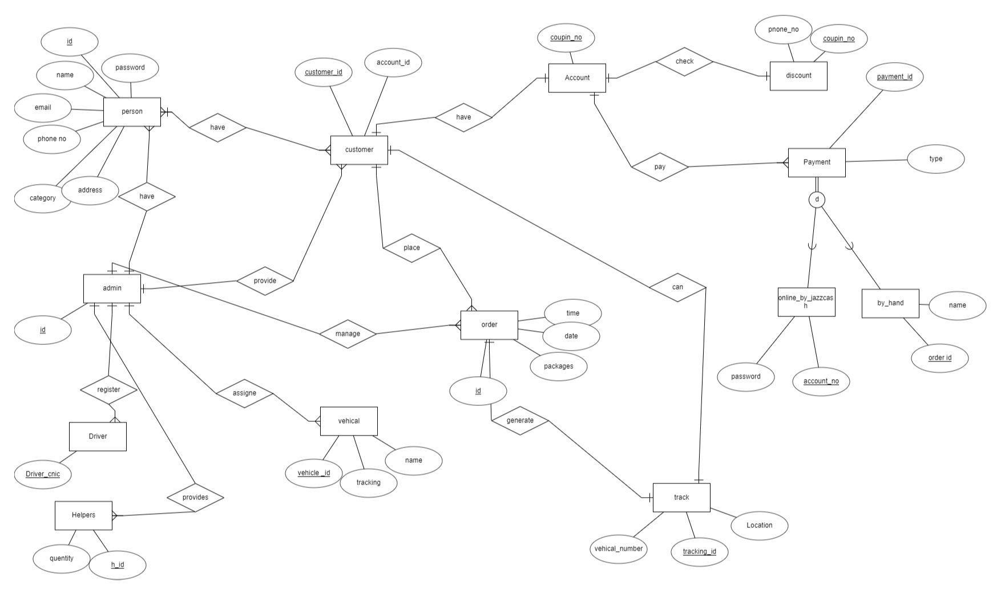

-

**Class diagram:**

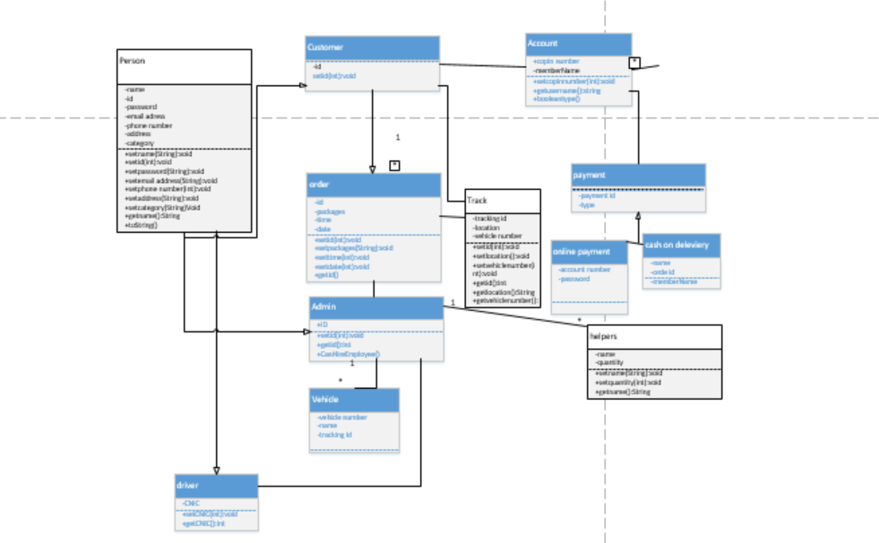

**Sequence Diagram:**

**Search vehicle:**

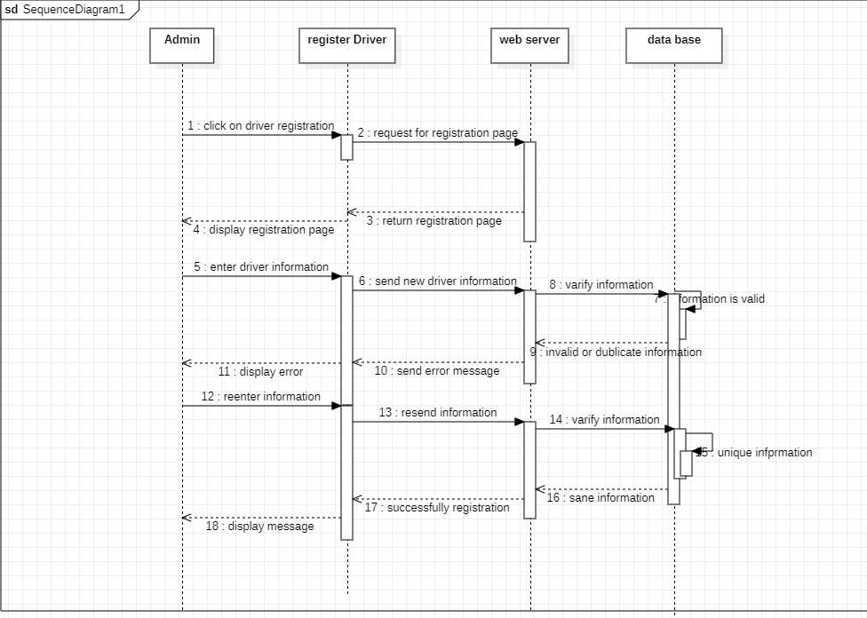

**Track order**

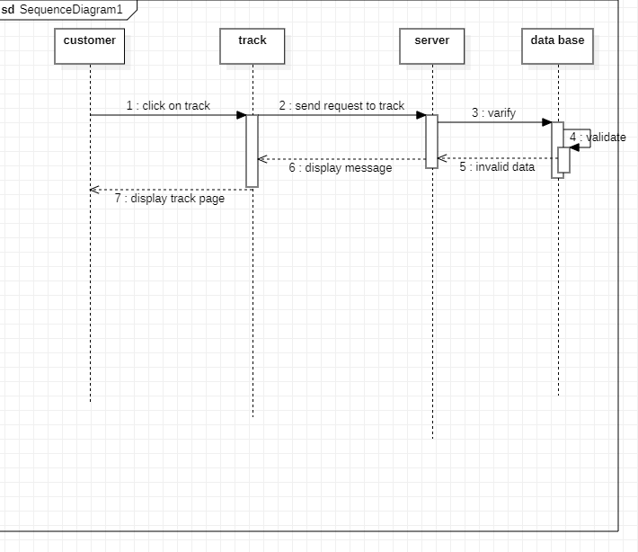

**Cancel Order**

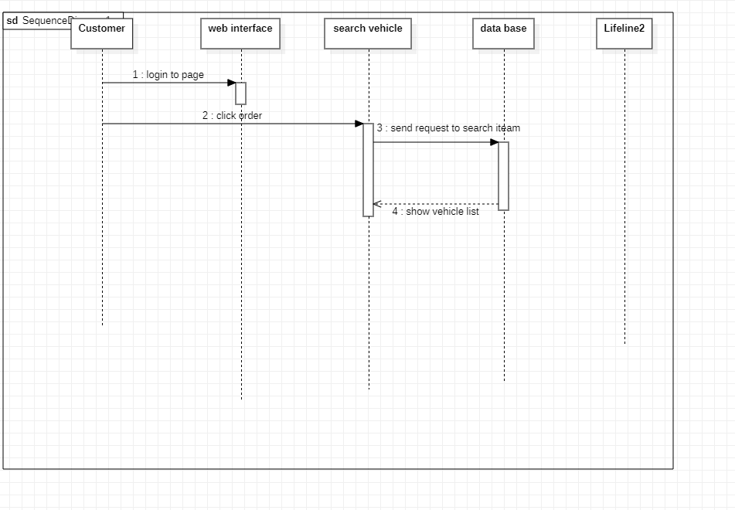

**Place order**

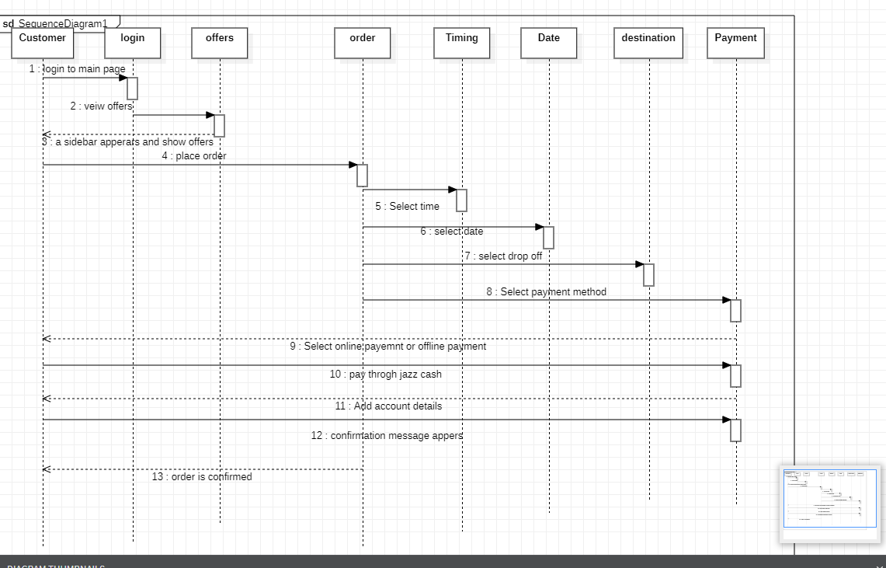

6. Detailed System Design

**Collaboration Diagram**

customer view

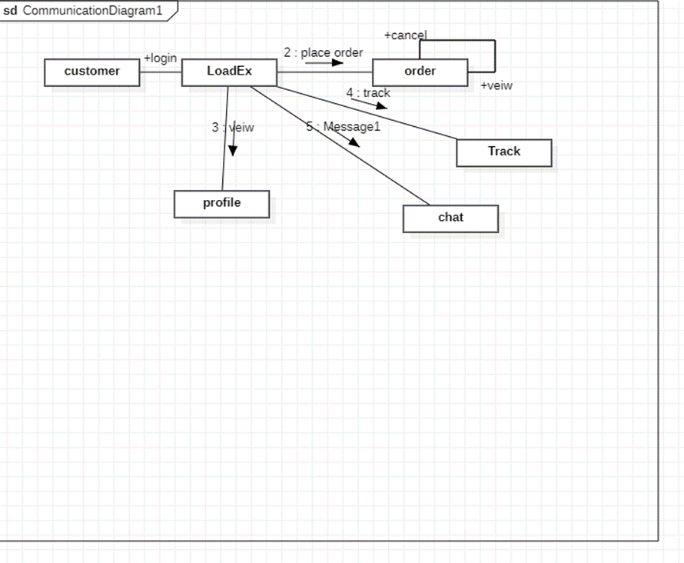-

**Admin View**

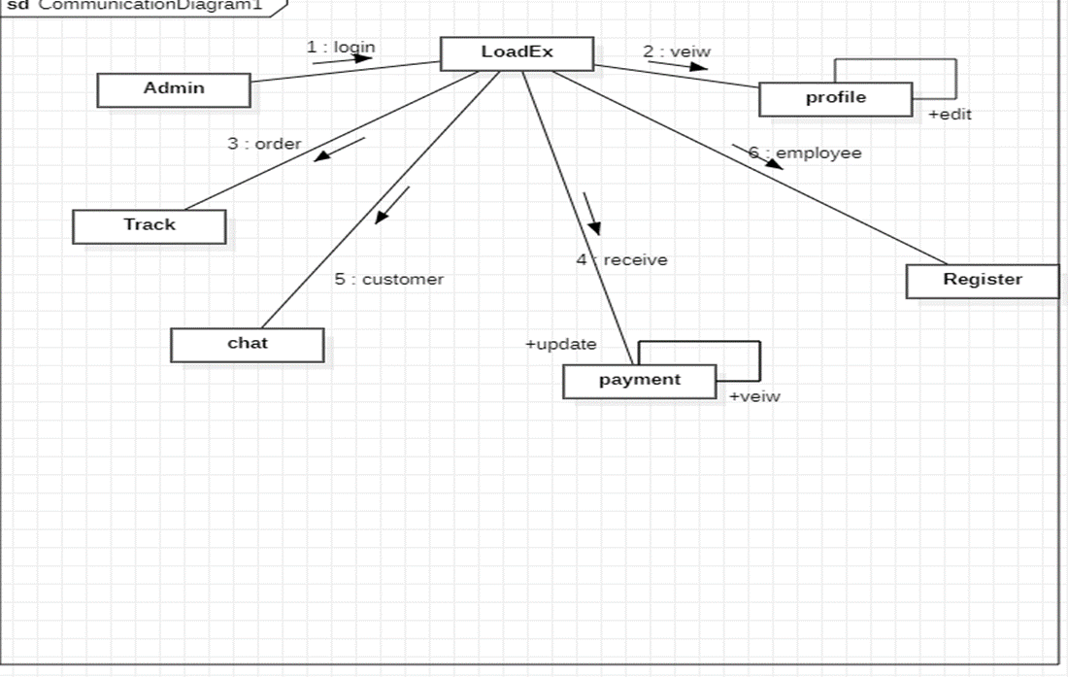

**System Architecture Diagram**

